Phenix Payton
NET2300
Sanitizer Enhanced Report
4/8/26
Test Clean (no virus) text file:
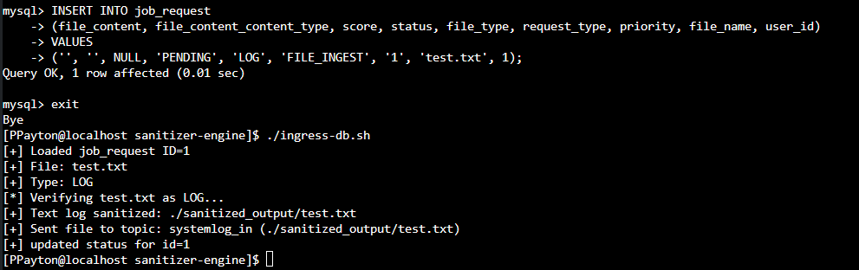
Successful sanitization and db entry:

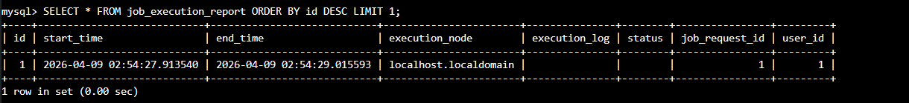

Test eicar (test virus signature) text file:
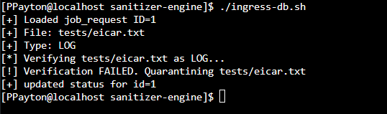
Sanitization failed and message quarantined:
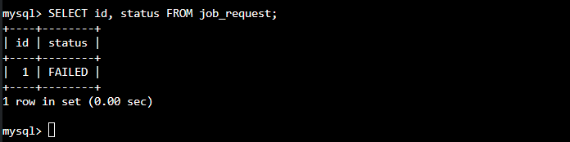

html complex sanitization:
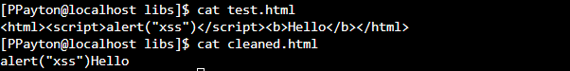
pcap complex sanitization:
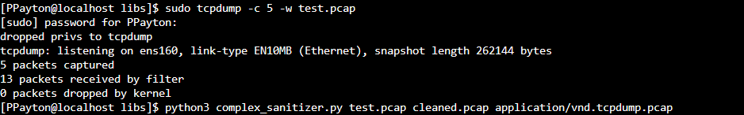
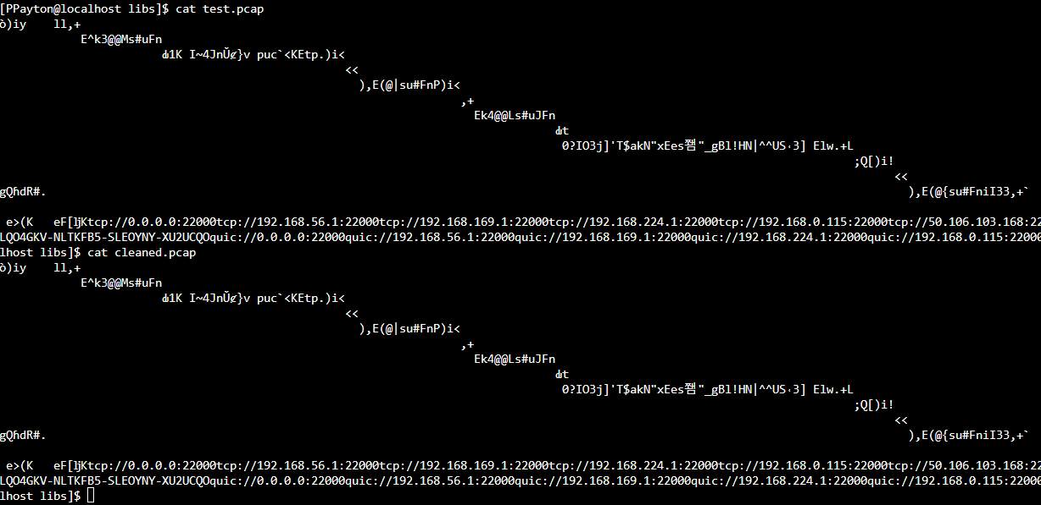
log complex sanitization:
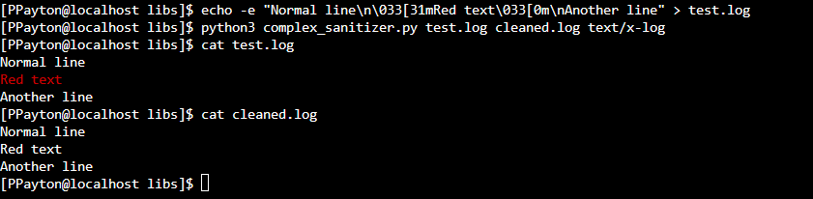
JSON complex sanitization:
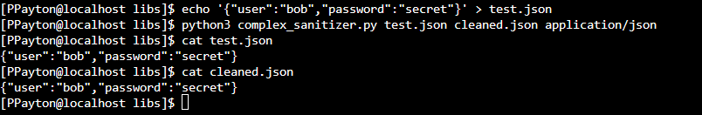
Error handling (File not found):
